- Plug in Raspberry Pi. Ensure it is connected to the RepRap

- Turn on power supply to the RepRap

- Log onto the DoES network on your computer.

- Navigate to octopi.local in your web browser

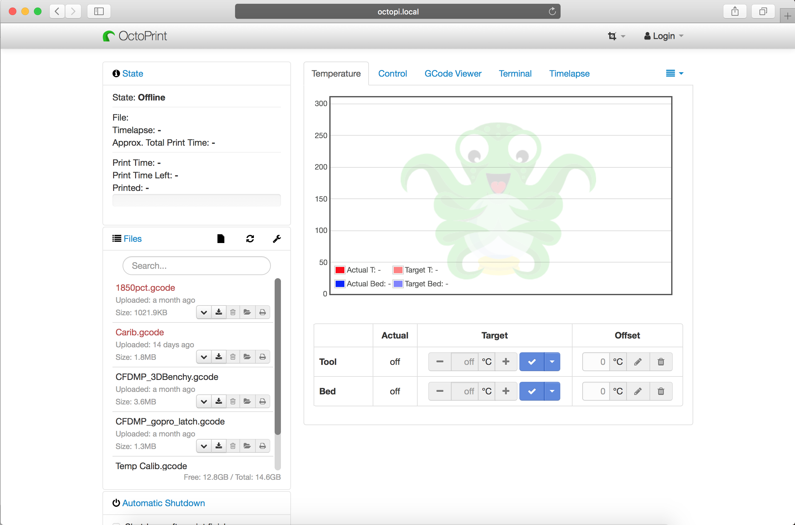

- Select Login

Username Liverpool

Passwork does

- Upload gcode file

drag and drop “upload locally”

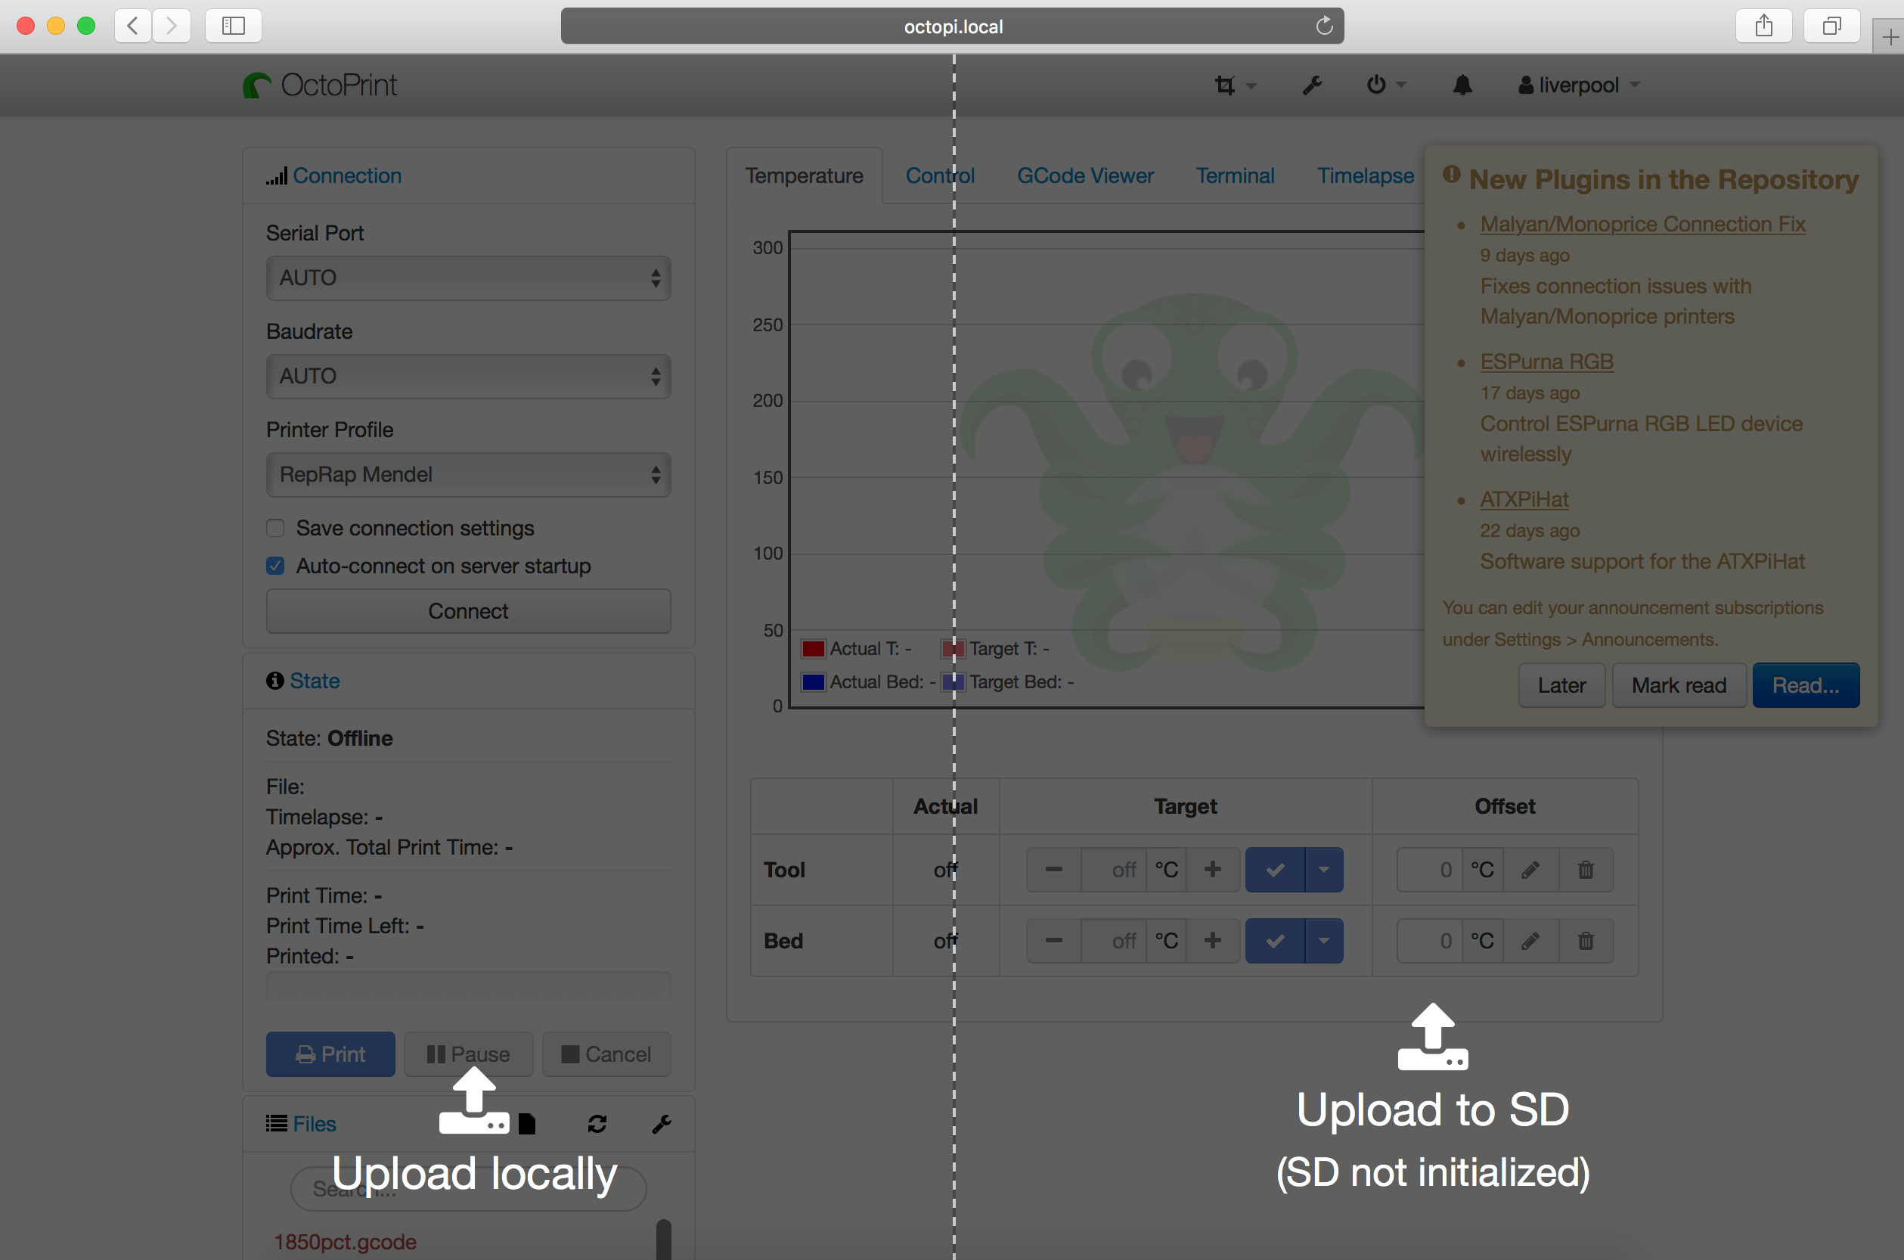

- Select “connect” to connect to RepRap printer.

- Select your file and click the printer icon to “load and print”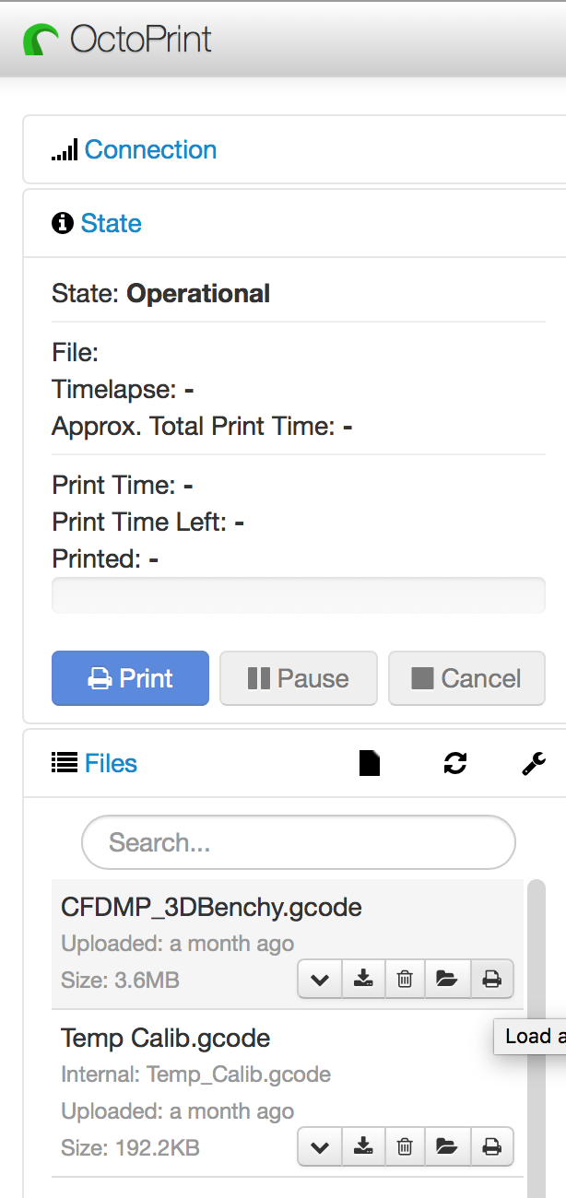

- after printing is complete, please shutdown the pi from the web interface before turning it off.

- turn off RepRap with the switch on the powersource.